BIKE KING BORDERS

Author: Supriya Biswas

Date:20/02/2019

Table of Contents

Introduction 3

Requirement Specification 4

Client Requirements 4

End Users 4

Design Constraints 4

Interface Designs 5

Design Justification 6

Colour 6

Typography / Fonts 6

Graphic Design Principles 6

Graphic Design Elements 6

Usability 6

# Introduction

I am Supriya Biswas an UI designer, I am hired to develop a webpage for bike king borders. my profession is to develop web pages. My experience is designing mobile applications and websites . I can honestly say it’s been an amazing journey!

Requirement Specification

Bike King Borders is a growing company based in the Borders region of Scotland. The company sell and repair road, mountain and hybrid bikes as well as sell a range of bike accessories and clothing. Also they hire out bikes for daily use on nearby off road bike trails. They are unique in the Borders due to their location and having the benefit of brilliant cycle trails on their doorstep. They pride themselves in selling only quality products and guaranteeing servicing and repair. The company currently use Facebook, Instagram and YouTube to advertise their location, products and services but now want a dedicated website that will display/ view well on all types of devices to help promote the business locally and to the tourist industry. Due to the increasing popularity of this sport, they anticipate a wide range of end-users and want a website that will appeal to the target clientele. They want the site to bring in more business and hence profits as well as promoting tourism in this area of Scotland. Most importantly the address, location, opening hours and contact details should be immediately obvious. The company currently have an existing logo and brand and would like to continue using these on their website. They would be happy to discuss improvements to the logo if required. They are looking for a website that is attractive, friendly but professional looking and conjures up excitement, adrenaline and the outdoors.

## Client Requirements

* Visitors new to the site should be able to register by themselves.
* Online payments/ orders and home delivery
* Details of all the products in the website with images
* Site visitors should be able to purchase goods or booking of services online.
* Users should be able to view a complete list of specified items available through the site.
* Users should be able to select items of interest and add them to their shopping carts for future purchase.
* Visitors should be able to delete items from their shopping carts before checkout.
* All selected items should be shipped to the user following purchase.
* Users should be able to view the status of items they have ordered.

## End Users

* Customers
* Employees handling Customer queries and orders
* Senior Management overviewing sales and reports
* Stakeholders/Investors

## Design Constraints

* The website should be able to auto resize based on the device mobile/tablet/desktop
* Website should be able to handle more than 1000 user concurrently
* Non Functional Constraints such as high performance/reliability and consistency

# Interface Designs

Mobile :

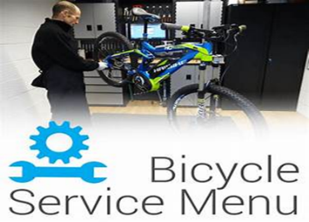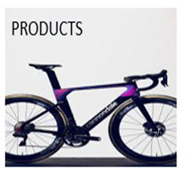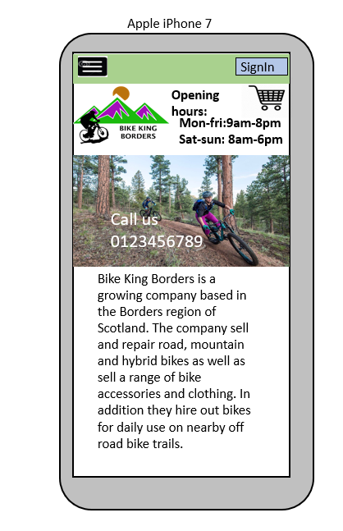

SERVICES & REPAIRS

# 

# 

# 

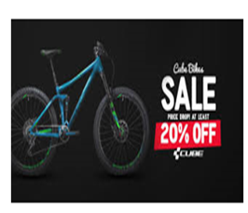

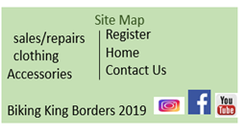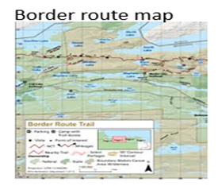

# 

# **iPad :**

Desktop:

# 

# Design Justification

I design the website according to the client and end users needs where I put all the content with link and navigation on the home page so that it will be easy for users to understand and search for the things they want. I have given less white space and clean images of all products and services in the home page so that users and client will find the website user friendly.

## Colour

I used the tint colour with white background as A tint lightens the colour, but it doesn't make it brighter. Even a small amount of white added to a colour, transforms it into a tint. So it will soothe eyes and brain while browsing.

## Typography / Fonts

I used Arial font because it’s one of the most widely used sans-serif fonts.

## Graphic Design Principles

* **Communication**: People on the web tend to want information quickly, so it is important to communicate clearly, and make information easy to read.
* **Images:** A picture can speak a thousand words, and choosing the right images for website can help with brand positioning and connecting with the target audience.
* **Navigation:** Navigation is about how easy it is for people to take action and move around the website, designing clickable buttons, and following the ‘three clicks rule’ which means users will be able to find the information they are looking for within three clicks.
* **Grid based layout**: Placing content randomly on web page can end up with a haphazard appearance that is messy. Grid based layouts arrange content into sections, columns and boxes that line up and feel balanced, which leads to a better-looking website design.

## Graphic Design Elements

* Keep content on the top which make the website look optimistic and visible location on the webpage.
* Clear and responsive images can help visually tell your story without having to rely on just text. Ensuring images are responsive makes for a good user experience. Website visitors can look at different images -- whether they are the background or product images and be able to get the same experience no matter what device they are coming from.

## Usability

* Good clarity of images and texts.
* Nice and simple design website where users will understand better about all the content.
* Credibility is very crucial so that people will know about the company and genuine website.
* Good usability requires thorough user research and an iterative approach of constant testing and refining.
* Good usability depends on whether the website is available, clear, credible, learnable, and relevant to the people who actually use it.